MATLAB programs chapter 1

Program1: A program to plot a vowel file ‘a’ and its Welch power spectral density estimate

clear all;
fp=fopen('c:/a.wav','r');

fseek(fp,21044,-1);
a=fread(fp,8000);
a=a-128;

plot(a);
xlabel('sample number');
ylabel('amplitude');
title('plot of the utterance i');
Fs = 22100; t = 0:1/Fs:.296;
h=spectrum.welch
d = psd(h,a,'Fs',Fs);
figure;% Calculate the PSD
plot(d);

Plot of Wave file and PDS estimate is shown below.
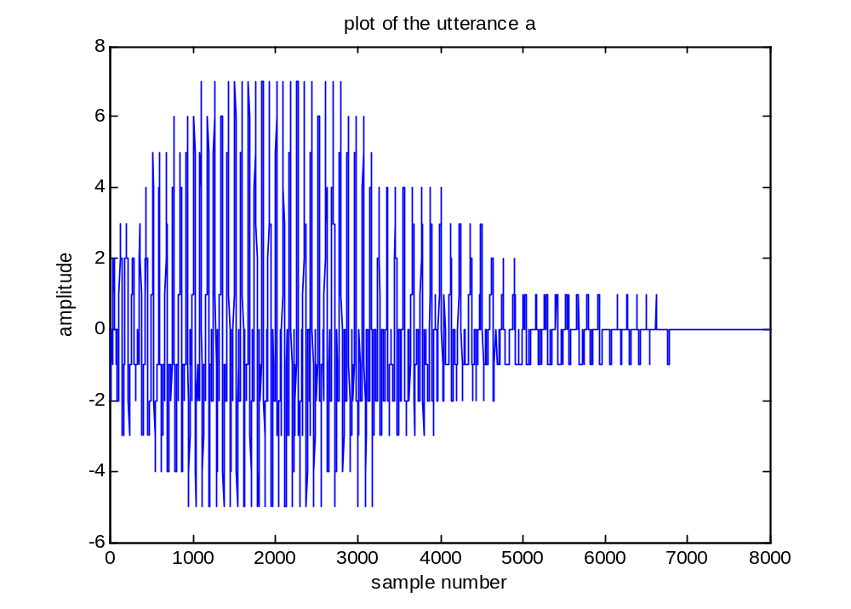

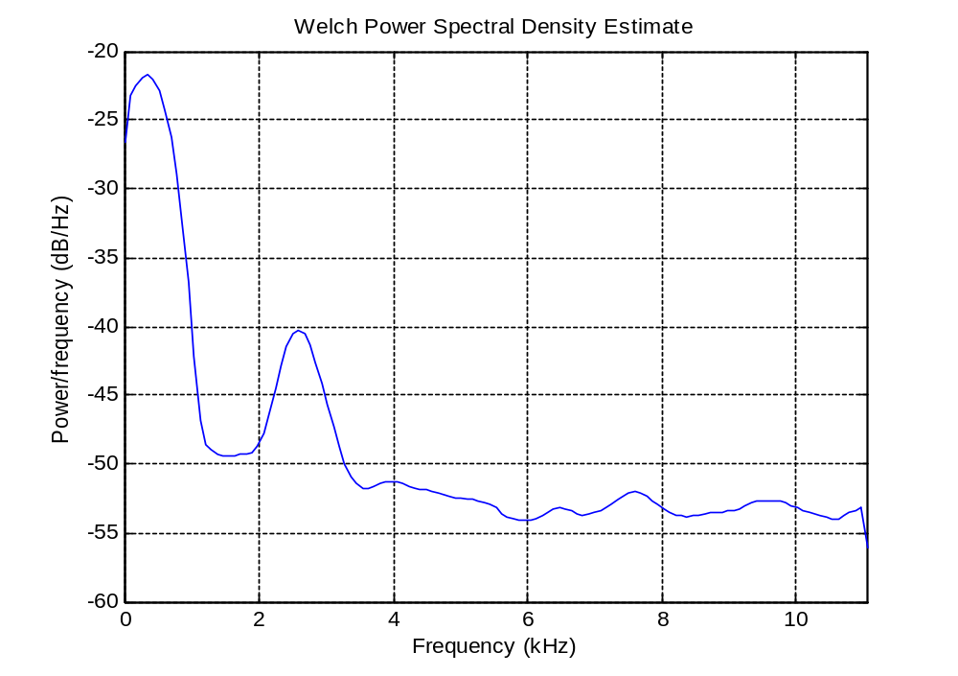

Program 2: For vowel ‘I’, the program is given below.
clear all;
fp=fopen('c:/i.wav','r');

fseek(fp,16044,-1);
a=fread(fp,8000);
a=a-128;

plot(a);
xlabel('sample number');
ylabel('amplitude');
title('plot of the utterance i');
Fs = 22100; t = 0:1/Fs:.296;
h=spectrum.welch
d = psd(h,a,'Fs',Fs);
figure;% Calculate the PSD
plot(d);

A plot of file and its PDS estimate using Welch method is given below.
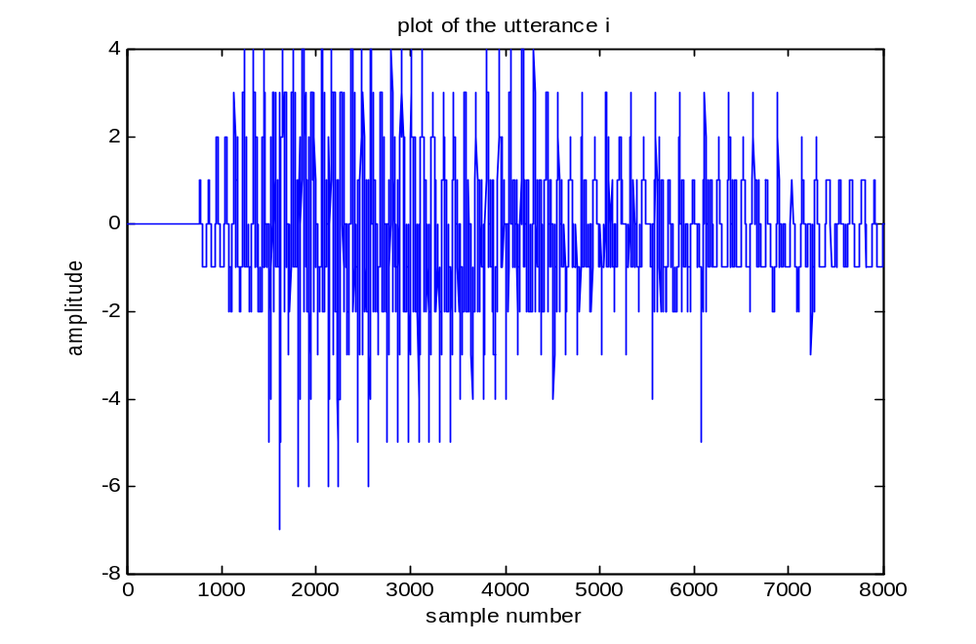
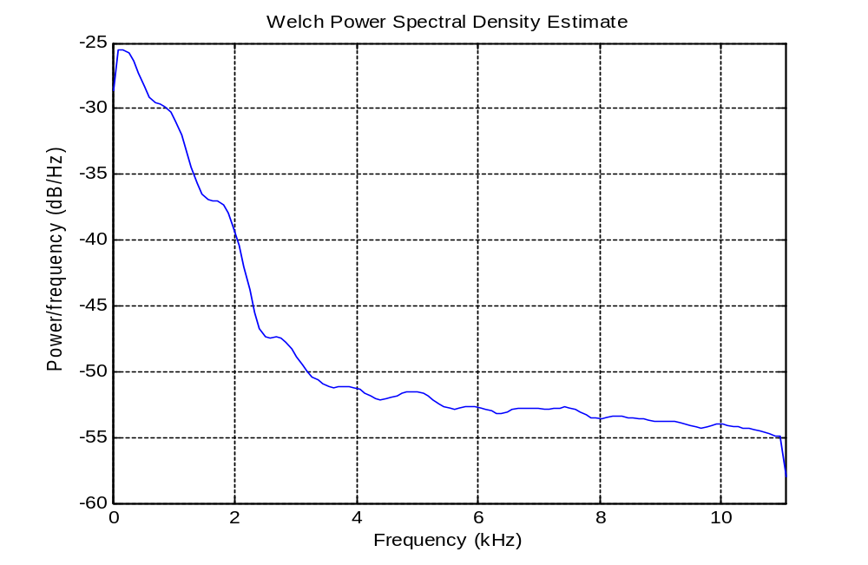
Program 3: A MATLAB program to calculate positive and negative ZCR for a voiced and unvoiced segment is given below.

clear all;
fp=fopen('watermark.wav');
fseek(fp,60044,-1);
a=fread(fp,10000);
plot(a);
xlabel('sample number'); ylabel('amplitude');title('plot of speech segment for 10000 samples');

% file read and plotted. We are reading first 10000 samples after fseek by 60000 samples.

x=0;
figure;
for i=5000:6999,
if (a(i)>128) && (a(i+1)<128)
x=x+1;
else x=x;

end
end
disp('number of zero crossings for voiced segment='); disp(x);

% samples between 5000 to 7000 are read and number of zero crossings are found..

fseek(fp,65044,-1);
b=fread(fp,2000);
plot(b);
xlabel('sample number'); ylabel('amplitude');title('plot of voiced speech segment');

% We are reading samples between 5000 to 7000 and are plotted. This is unvoiced segment.

figure;
for i=7000:8999,
if (a(i)>128) && (a(i+1)<128)
x=x+1;
else x=x;

end
end
disp('number of zero crossings for unvoiced segment='); disp(x);

% samples between 7000 to 9000 are read and number of zero crossings are found..

fseek(fp,67044,-1);
c=fread(fp,2000);
xlabel('sample number'); ylabel('amplitude');title('plot of unvoiced speech segment');
plot(c);

% We are reading samples between 7000 to 9000 and are plotted. This is unvoiced segment

Output of MATLAB program is –
number of negative zero crossings for voiced segment=
135

number of negative zero crossings for unvoiced segment=
193
A plot of voiced and unvoiced segment is given below.
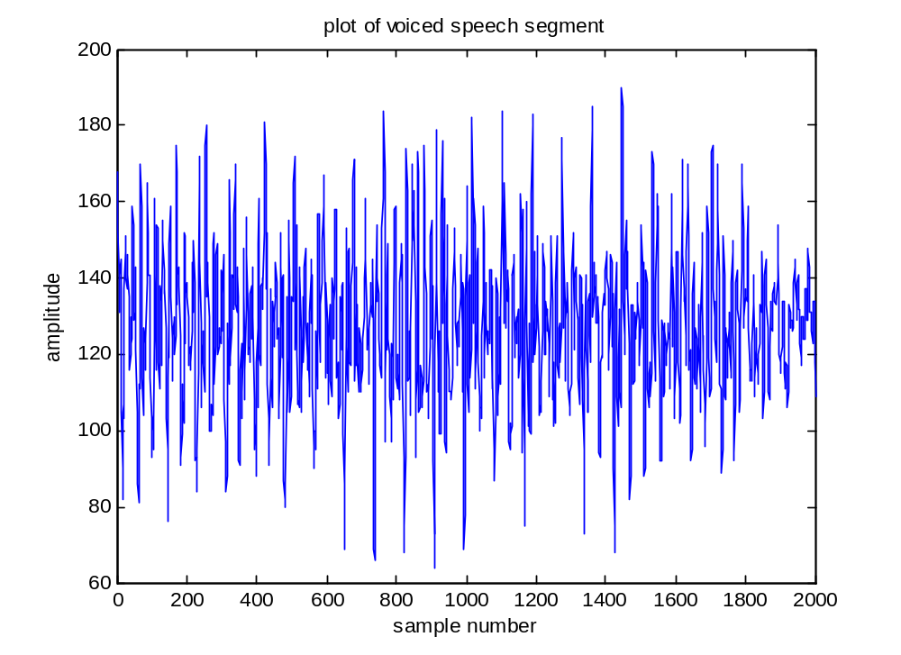
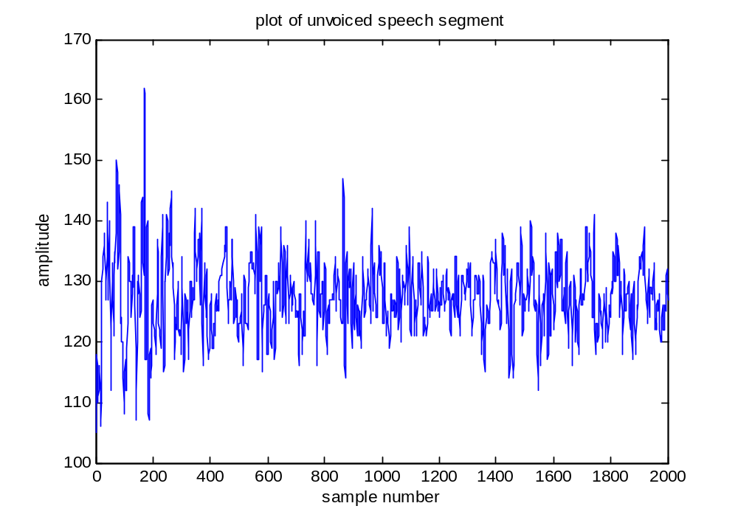

Program 4:
A MATLAB program to detect the spectrum tilt is given below.
%to find spectrum tilt for speech signal
clear all;
fp=fopen('c:/h.wav');
fseek(fp,44,-1);
a=fread(fp);
a=a-128;

subplot(2,1,1);plot(a);title('plot of speech signal');
xlabel('sample no.');ylabel('amplitude');

for j=1:750,
fseek(fp,44+100*j,-1);
a=fread(fp,100);
a=a-128;
sum(j)=0;
for i=2:100,
sum(j)=sum(j)+(a(i)*a(i-1));

end
sum1(j)=0;
for i=2:100,
if a(i)==0,
a(i)=0.1;
end
sum1(j)=sum1(j)+a(i)*a(i);

end
s(j)=sum(j)/sum1(j);
end

subplot(2,1,2);plot(s);title('plot of spectrum tilt of speech signal');
xlabel('segment number');ylabel('value of spectrum tilt');

A plot of spectrum tilt is given below.
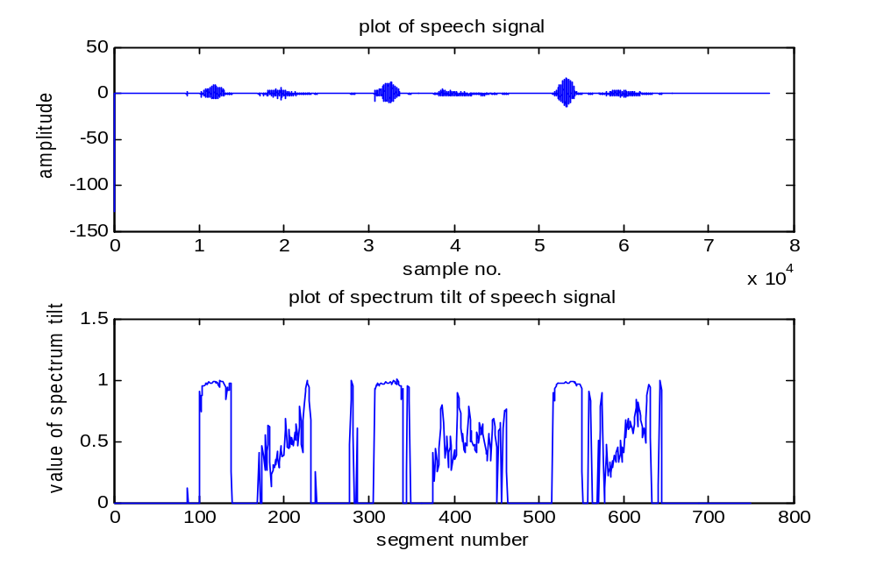
We have used a speech file containing voiced and unvoiced segments. The plot of spectrum tilt in Figure 1.25 shows that when a signal is voiced, the spectrum tilt has value very close to one whereas for unvoiced segment, spectrum tilt is less than one. In case of silence part, the spectrum tilt is close to zero. Hence, using spectrum tilt, one can identify the voiced, unvoiced and silence part of the utterance.
Program 5: A MATLAB program to plot pre-emphasized energy is given below.
%to find pre-emphasized energy ratio for speech signal
clear all;
fp=fopen('c:/h.wav');
fseek(fp,44,-1);
a=fread(fp);
a=a-128;

subplot(2,1,1);plot(a);title('plot of speech signal');
xlabel('sample no.');ylabel('amplitude');

for j=1:750,
fseek(fp,44+100*j,-1);
a=fread(fp,100);
a=a-128;
sum(j)=0;
for i=2:100,
sum(j)=sum(j)+abs(a(i)-a(i-1));

end
sum1(j)=0;
for i=2:100,
if a(i)==0,
a(i)=0.1;
end
sum1(j)=sum1(j)+a(i)*a(i);

end
s(j)=sum(j)/sum1(j);
end

subplot(2,1,2);plot(s);title('plot of pre-emphasized energy ratio of speech signal');
xlabel('segment number');ylabel('value of pre-emphasized energy ratio');

We have used a speech file containing voiced and unvoiced segments. The plot of pre-emphasized energy ratio in Figure below shows that when a signal is voiced, the pre-emphasized energy ratio has value very close to zero whereas for unvoiced segment, pre-emphasized energy ratio is high. In case of silence part, the pre-emphasized energy ratio is zero. Hence, using pre-emphasized energy ratio, one can identify the voiced, unvoiced and silence part of the utterance.
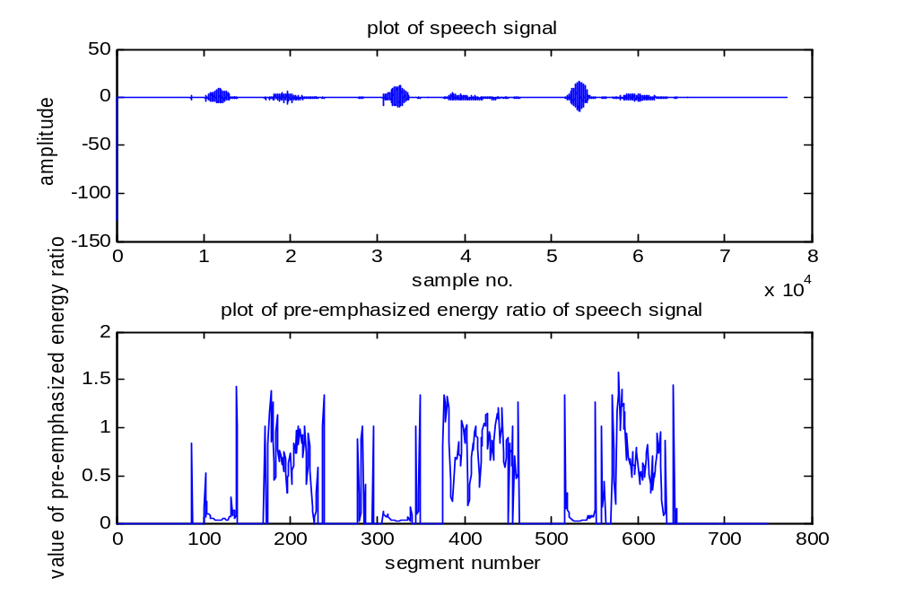
Program 6: A MATLAB program to plot pre-emphasized energy is given below.
%to find pre-emphasized energy ratio for speech signal
clear all;
fp=fopen('c:/h.wav');
fseek(fp,44,-1);
a=fread(fp);
a=a-128;

subplot(2,1,1);plot(a);title('plot of speech signal');
xlabel('sample no.');ylabel('amplitude');

for j=1:750,
fseek(fp,44+100*j,-1);
a=fread(fp,100);
a=a-128;
sum(j)=0;
for i=2:100,
sum(j)=sum(j)+abs(a(i)-a(i-1));

end
sum1(j)=0;
for i=2:100,
if a(i)==0,
a(i)=0.1;
end
sum1(j)=sum1(j)+a(i)*a(i);

end
s(j)=sum(j)/sum1(j);
end

subplot(2,1,2);plot(s);title('plot of pre-emphasized energy ratio of speech signal');
xlabel('segment number');ylabel('value of pre-emphasized energy ratio');

We have used a speech file containing voiced and unvoiced segments. The plot of pre-emphasized energy ratio in Figure below shows that when a signal is voiced, the pre-emphasized energy ratio has value very close to zero whereas for unvoiced segment, pre-emphasized energy ratio is high. In case of silence part, the pre-emphasized energy ratio is zero. Hence, using pre-emphasized energy ratio, one can identify the voiced, unvoiced and silence part of the utterance.

Figure 1.26 Plot of speech signal and pre-emphasized energy ratio

Program 7: A MATLAB program to calculate low band to full band energy ratio is given below.
%to find spectrum tilt for speech signal
clear all;
fp=fopen('c:/h.wav');
fseek(fp,44,-1);
a=fread(fp);
a=a-128;

subplot(2,1,1);plot(a);title('plot of speech signal');
xlabel('sample no.');ylabel('amplitude');

for j=1:750,
fseek(fp,44+100*j,-1);
a=fread(fp,100);
a=a-128;
for i=1:50,
b=abs(fft(a));
end
sum(j)=0;
for i=1:12,
sum(j)=sum(j)+(b(i));

end
sum1(j)=0;
for i=1:50,

sum1(j)=sum1(j)+b(i);
if sum1(j)==0;
sum1(j)=1;
end
end
s(j)=sum(j)/sum1(j);
end

subplot(2,1,2);plot(s);title('plot of low to full band enery ratio of speech signal');
xlabel('segment number');ylabel('value of low to full band energy ratio');
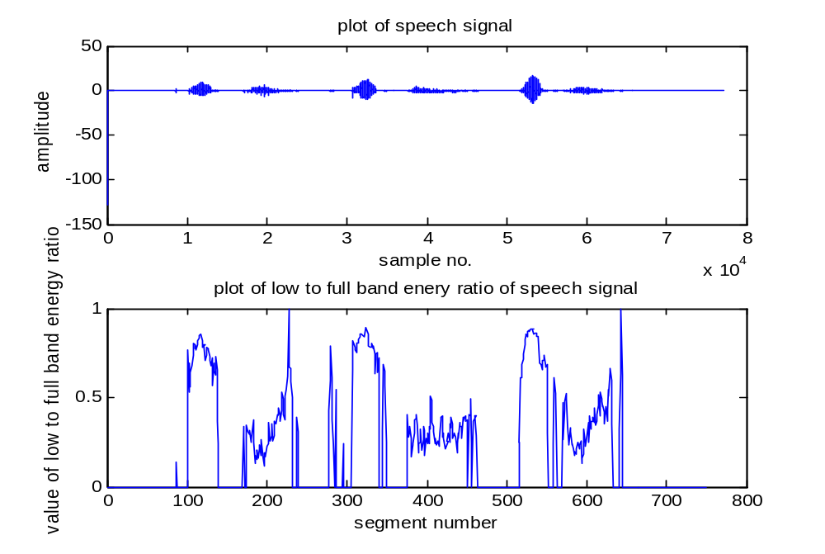
Figure 1.27 Plot of signal and its low to full band energy ratio

We have used a speech file containing voiced and unvoiced segments. The plot of Low band to full band energy ratio in Figure above shows that when a signal is voiced, the pre-emphasized energy ratio has maximum value whereas for unvoiced segment, low to full band energy ratio is low. In the program we have taken the ratio of 1/4th band to full band. In case of silence part, the low band to full band energy ratio is zero. Hence, using low band to full band energy ratio, one can identify the voiced, unvoiced and silence part of the utterance.

